Process and Procedure Names:  - Process: IT Management Operating System  - Procedure: HUE within IT Waterfall/Agile Projects | Work Instruction Name:  System Usability Scale | Effective Date: 01-Nov-2017
Work Instruction Owner:  Madhumita Gupta | Work Instruction Name:  System Usability Scale | Revision Date: 08-Dec-2017

Purpose

The purpose of utilizing the System Usability Scale (SUS) is to measure the user satisfaction of an offering that either already exists or which is under development (e.g. as a prototype). HUE training is a prerequisite: Usability Testing – only refer to the SUS part of the training.

Scope
This work instruction is how to utilize the SUS survey and analyze the results.

Work Instruction Activities

Step # | Description | Owner (Role) | Details (e.g. screenshots, charts, etc.)
 | Determine what persona(s) are needed as SUS survey participants | HUE Expert | Refer to Work Instruction “Personas”.  Learn more about SUS here.
 | Create a SUS survey online using Survey Monkey or print the SUS questionnaire to capture responses manually |  | Refer to System Usability Scale (SUS) questionnare
 | Make sure to provide the SUS questionnaire only to users who have just experienced the software you want to measure. This can be done through:  - Usability testing where the SUS is filled out by test participants at the end of the test  and/or  - Intercept surveys which show the SUS after a user has completed a workflow with software | HUE Expert | If your project is about enhancing or replacing an existing product, the SUS should be applied for that legacy product in order to establish a UX baseline measure against which iterations of the new product can be compared.
 | Once the SUS responses are captured, use the SUS calculator to calculate the SUS Score | HUE Expert | Refer to SUS Calculation Spreadsheet
6. | Review and interpret the resulting SUS score with the project team and derive action items as needed. |  | 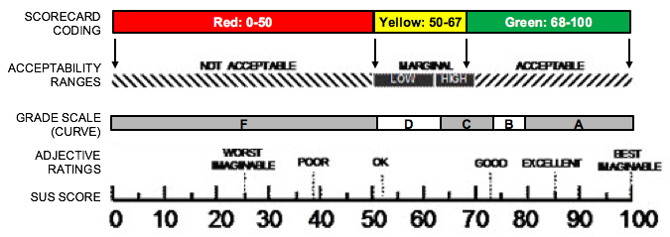
7. | Store SUS score as project artefact on a shared location along with the usability testing report. | HUE Expert | Feel free to use the Usability Test Results Presentation template.

Enforcement

Failure to adhere to published policies, processes, procedures, work instructions and standards will be evaluated on a case by case basis and may result in disciplinary action. Published policies, processes, procedures, work instructions and standards are also subject to audit by Honeywell Corporate Audit and external auditors for verification of compliance.

Version Control and Review Frequency

This Procedure is to be reviewed at minimum annually.

Date Last Reviewed: 08-Dec-2017
Reviewed By: Tobias Komischke, IT HUE Leader

Version # | Effective Date | Section(s) | Description | Author | Content/SME  Approval | Work Instruction Owner Approval
1.0 | 01-Nov2017 | Full document | First version | Madhumita Gupta | Tobias Komischke | Tobias Komischke
1.1 | 08-Dec-2017 | All | Formatting edits based on Process Change Register requests | Tobias Komischke | Madhumita Gupta | Tobias Komischke
*Process Owner, Process Governance and External Compliance approvals are through the automated tool

